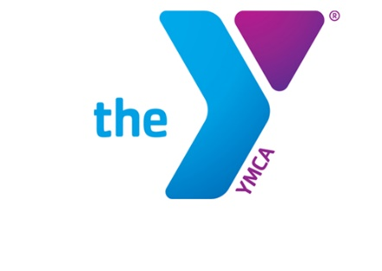

Newton YMCA/Monsignor McCann
Spring 2024 Youth Soccer Schedule -
Pre K 4 &5 Division II

Team Coach Team Name Phone #
Team 1 Tonya & Andrew Mahr Goal Getters 641-891-2065
Team 2 Victoria Peters Aces 712-369-1772
Team 3 Shannon Rojohn Typhoon 641-275-8974
Team 4 Grant McDermott Anteaters 641-521-8146
Team 5 Sarah Hartgers Eagles 641-521-7379
Team 6 Ethan Vass Shooting Stars 712-540-4276

Time | April 13 | April 20 | April 27
8:30 | 2 vs 5 | 4 vs 6 | 2 vs 3
9:00 | 1 vs 4 | 3 vs 5 | 4 vs 5
9:30 | 3 vs 6 | 1 vs 2 | 1 vs 6
Time | May 4 | May 11 | May 18
8:30 | 1 vs 3 | 1 vs 5 | 2 vs 5
9:00 | 2 vs 4 | 2 vs 6 | 3 vs 6
9:30 | 5 vs 6 | 3 vs 4 | 1 vs 4

- All games played Saturday morning on Pre K field II
- League is 3 v 3 with no goalie

Newton YMCA
1701 S. Eighth Ave. E
Newton, Iowa 50208
(p) 641-792-4006
(e) scott.taylor@newtonymca.org

