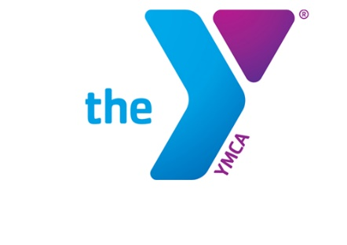

Newton YMCA/Monsignor McCann
Spring 2024 Youth Soccer Schedule -
Pre K 4 &5 Division IV

Team Coach Team Name Phone #
Team 1 Danielle Brennan The Swarm 515-669-4860
Team 2 Danny Samson Crickets 515-402-2572
Team 3 Alyssa Plunkett Thunder 319-784-8221
Team 4 Trent Williams Avengers 641-275-5309
Team 5 Taylor Springer Wild 641-275-5212
Team 6 Ryan Riggs Roadrunners 319-230-5519

Time | April 13 | April 20 | April 27
10:15 | 2 vs 5 | 4 vs 6 | 2 vs 3
10:45 | 1 vs 4 | 3 vs 5 | 4 vs 5
11:15 | 3 vs 6 | 1 vs 2 | 1 vs 6
Time | May 4 | May 11 | May 18
10:15 | 1 vs 3 | 1 vs 5 | 2 vs 5
10:45 | 2 vs 4 | 2 vs 6 | 3 vs 6
11:15 | 5 vs 6 | 3 vs 4 | 1 vs 4

- All games played Saturday morning at the Newton YMCA
- All games in the division played on Pre K Field 2
- League is 3 v 3 with no goalie

Newton YMCA
1701 S. Eighth Ave. E
Newton, Iowa 50208
(p) 641-792-4006
(e) scott.taylor@newtonymca.org

