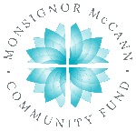
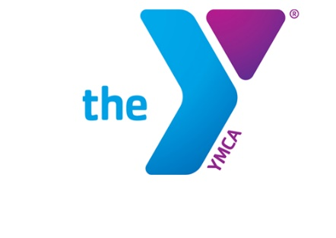

Newton YMCA/Monsignor McCann
Spring 2024 Youth Soccer Schedule -
U7 Girls

Team Coach Team Name Phone #
Team 1 Nicole Woods England 515-321-3282
Team 2 Cassidy Mathews Japan 641-840-0711
Team 3 Hannah Bennett Spain 641-521-4397
Team 4 Hannah Bennett Netherlands 641-521-4397
Team 5 Kayla Eicher Wales 641-521-4403
Team 6 Chantele Maxwell Belgium 515-689-1635

Time | April 13 | April 20 | April 27
2:00 | 2 vs 5 | 4 vs 6 | 2 vs 3
2:50 | 1 vs 4 | 3 vs 5 | 4 vs 5
2:50 PSF1 | 3 vs 6 | 1 vs 2 | 1 vs 6
Time | May 4 | May 11 | May 18
2:00 | 1 vs 3 | 1 vs 5 | 2 vs 5
2:50 | 2 vs 4 | 2 vs 6 | 3 vs 6
2:50 PSF1 | 5 vs 6 | 3 vs 4 | 1 vs 4

- All games played Saturday morning on YMCA fields
- League is 4 v 4 with no goalie
- PSF1 = Pre School-Field 1

Newton YMCA
1701 S. Eighth Ave. E
Newton, Iowa 50208
(p) 641-792-4006
(e) scott.taylor@newtonymca.org

